


ANSYS LAB 1
Sec 2
Team 4

1-D Element Analysis
  - Machine Construction
  - Members
Name | ID
Omnia Raafat Sweed | 2200484
Basant Aref Mahmoud | 2200379
Mohammad Amr Attia El Zaafarany | 2200587
Mohamed Ayman Rashad | 2200803
Toqa Mohamed Gaber | 2200476
Nouran Abdelmounem Mohamed | 2200273
Sama Mohamed Abd El-Halim | 2200336
Yehia Farid Salama | 2201324
Mohammed Hany Mohammed | 2201377

Submitted to Eng. Islam Maged

Table of Contents
Objectives 2
Solutions 3
Problem 5 3
Using Workbench 3
Step 1: Preprocessing – Editing Engineering Data 3
Step 2: Preprocessing – Editing Geometry 4
Step 3: Preprocessing – Editing Model – Adjusting Mesh 4
Step 4: Preprocessing – Editing Model – Boundary Conditions 5
Step 5: Postprocessing – Directional Deformation 5
Step 6: Postprocessing – Stress Measurement 6
Step 7: Postprocessing – Deformation 6
Step 7: Postprocessing – Stresses 7
Step 8: Postprocessing – Tabulate Results 12
Using APDL 13
APDL SCRIPT Steps 13
APDL SCRIPT 14
Results 17

J
- Knowledge and understanding of finite element analysis of 1D Elements
- Ability to use Ansys Mechanical to set up a 1D structural simulation
- Awareness of the importance of simulation in engineering design

Objectives

Solutions

Problem 5
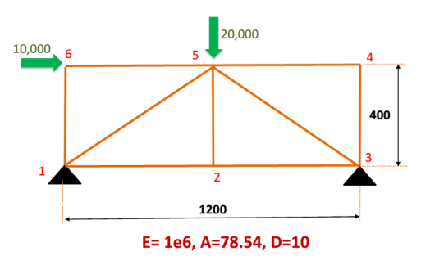

Using Workbench
J
Description
Change Young’s Modulus value to 1E6 Pa.

Step 1: Preprocessing – Editing Engineering Data

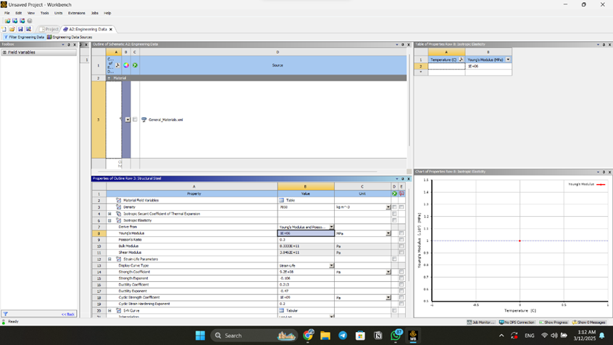

J
Description
Draw structure using design modeler and add cross-section.

Step 2: Preprocessing – Editing Geometry

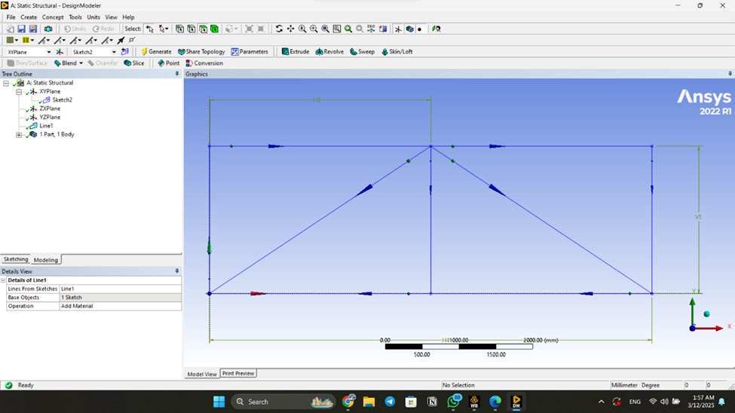

J
Description
Choosing an appropriate initial mesh resolution for model, 5.

Step 3: Preprocessing – Editing Model – Adjusting Mesh

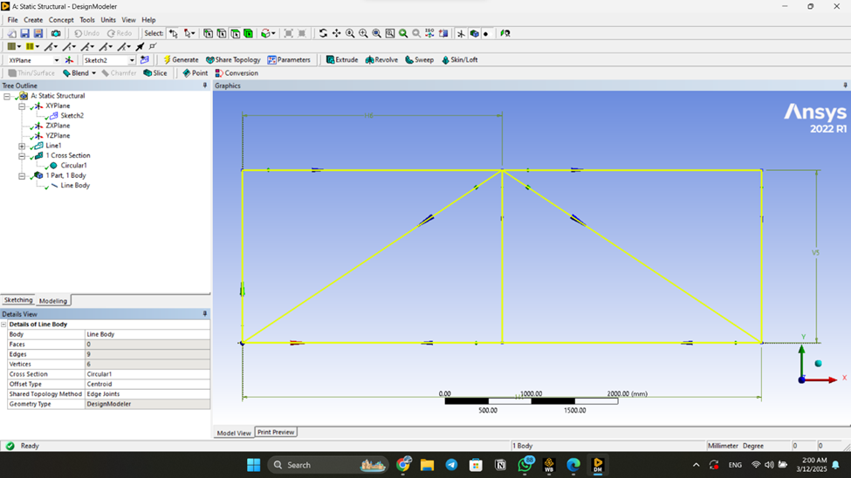

J
Description
Insert forces and fixation to structure.

Step 4: Preprocessing – Editing Model – Boundary Conditions

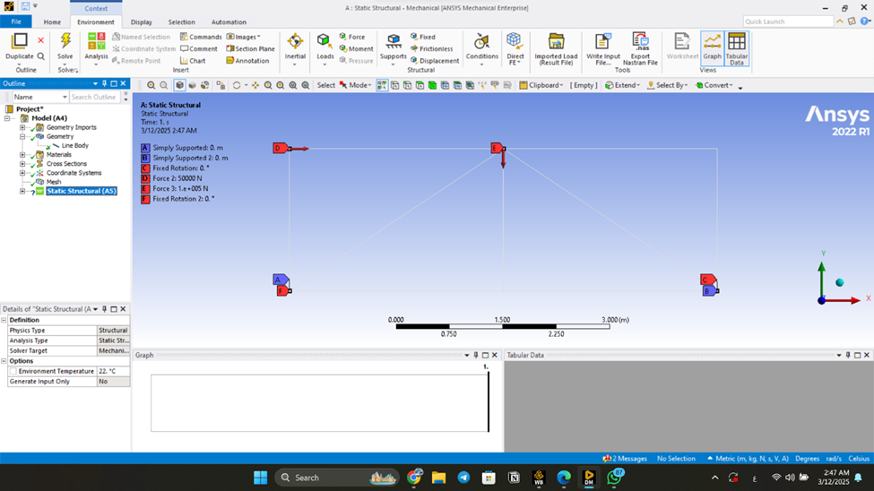

J
Description
Insert directional deformation to solution and choose all body as scope geometry.

Step 5: Postprocessing – Directional Deformation

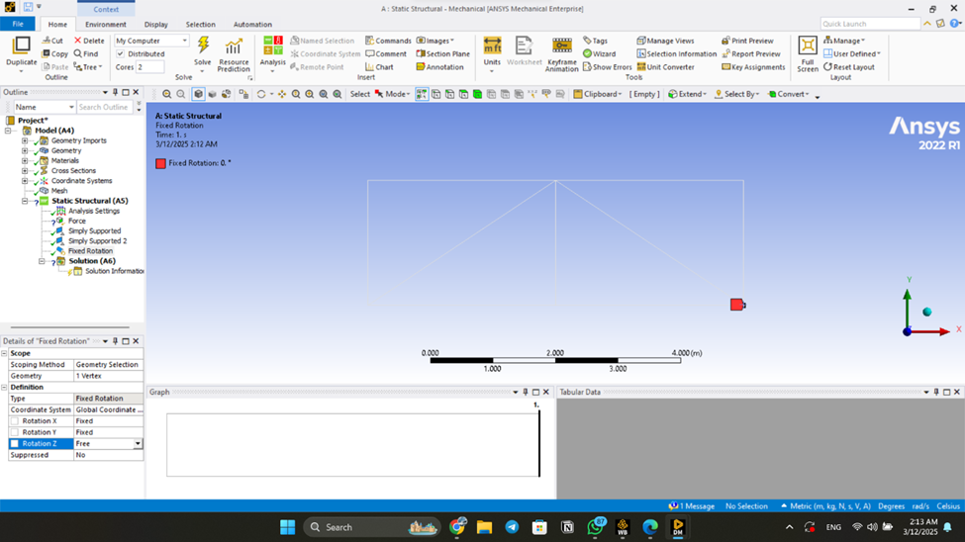

J
Description
Insert beam tool for each beam to solution and choose the beams of the structure as scope geometry.

Step 6: Postprocessing – Stress Measurement

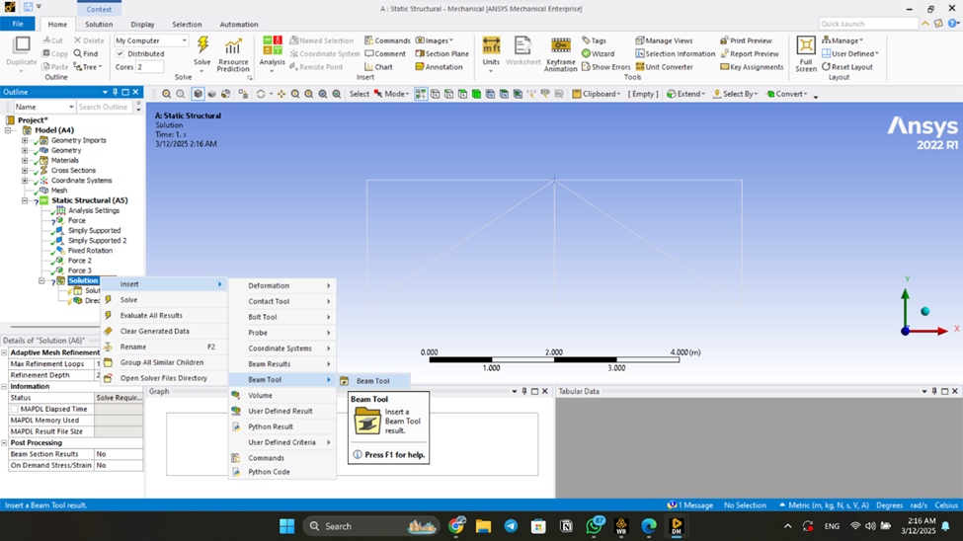

J
Description
Press on solve and get total deformation.

Get directional deformation.

Step 7: Postprocessing – Deformation

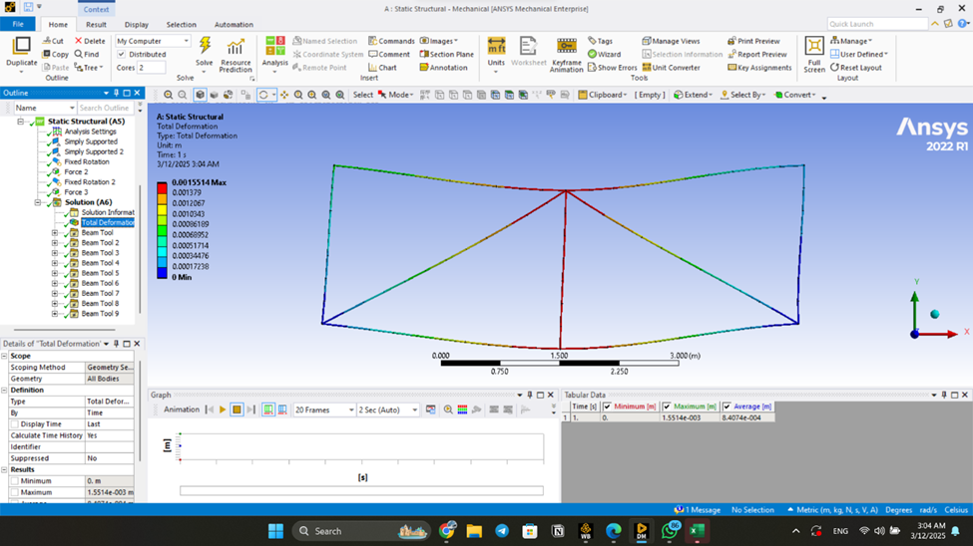

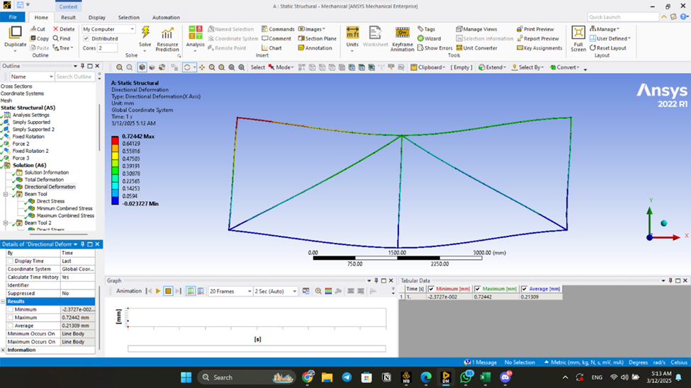

J
Description
Get stress on each beam.

Step 7: Postprocessing – Stresses

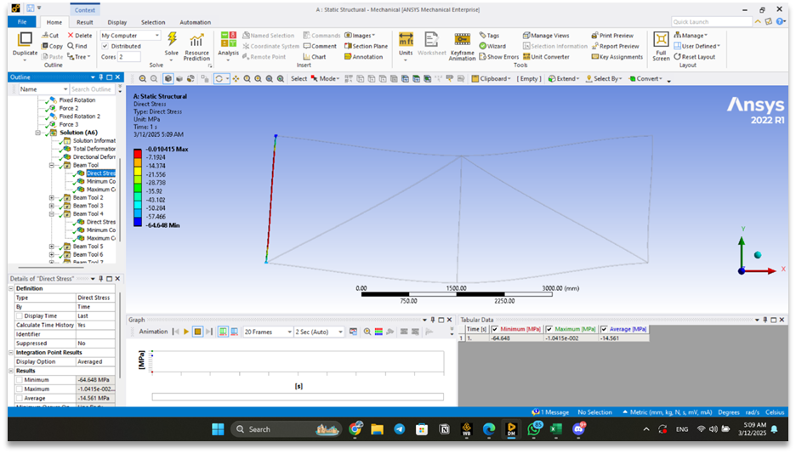

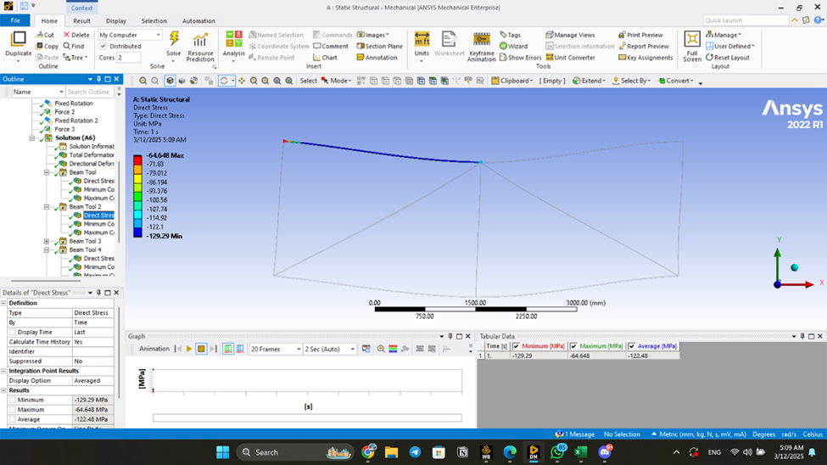

J
Description
Get stress on each beam.
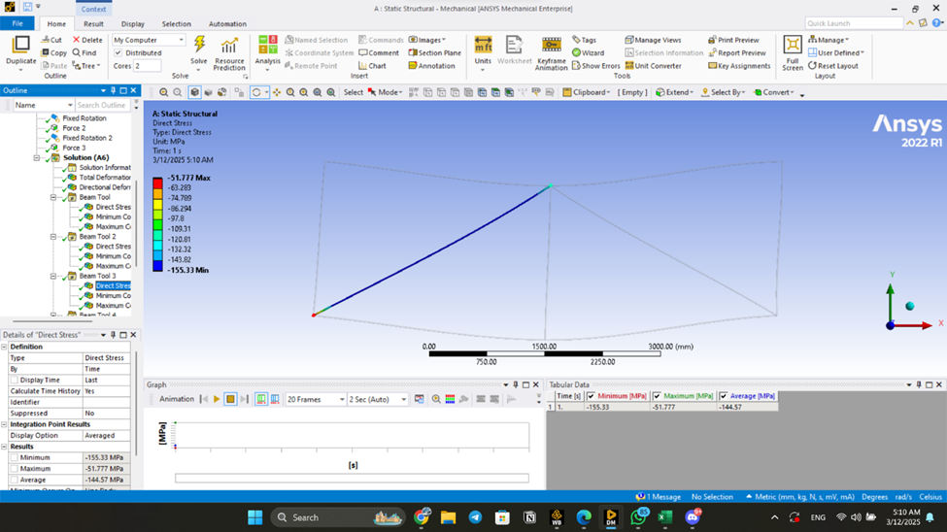

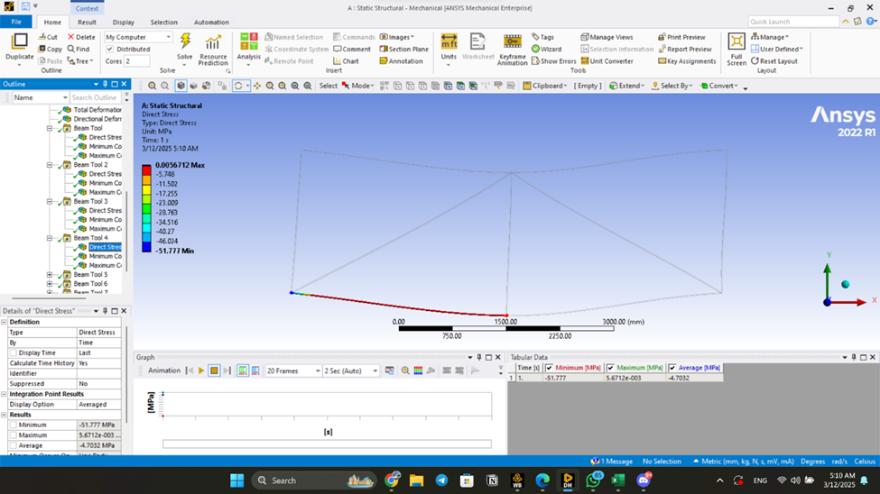

Step 7: Postprocessing – Stresses

J
Description
Get stress on each beam.

Step 7: Postprocessing – Stresses

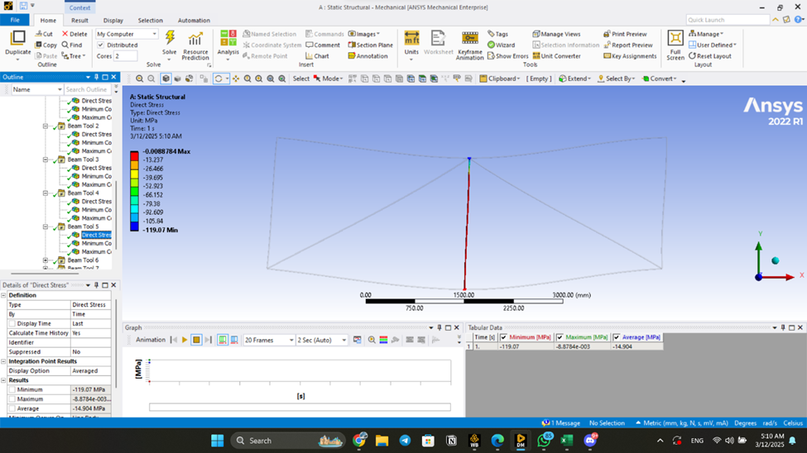

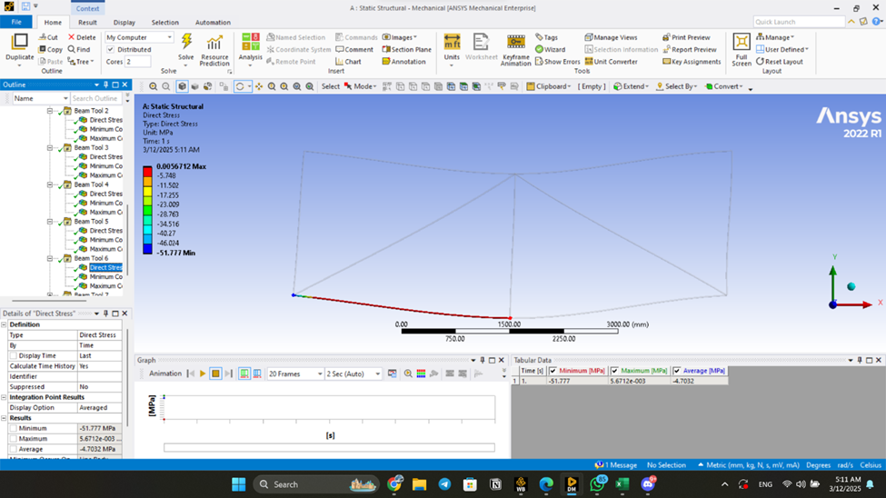

J
Description
Get stress on each beam.

Step 7: Postprocessing – Stresses

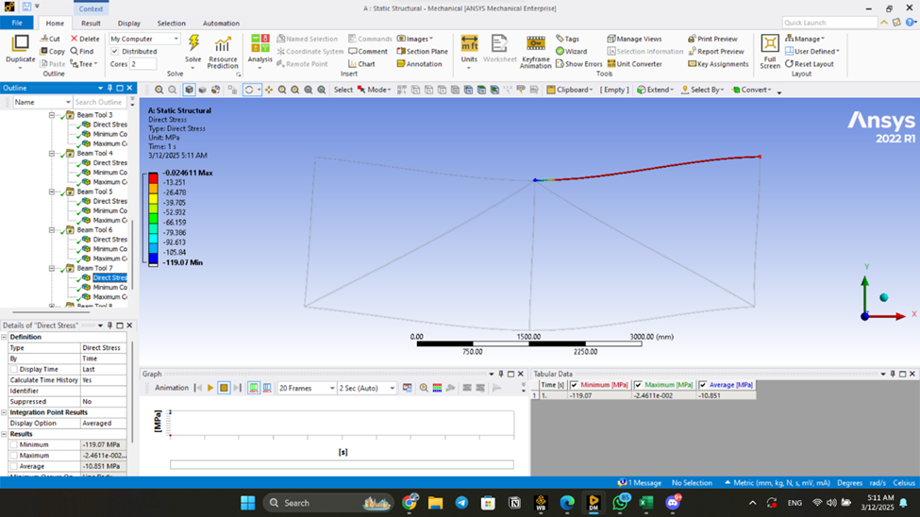

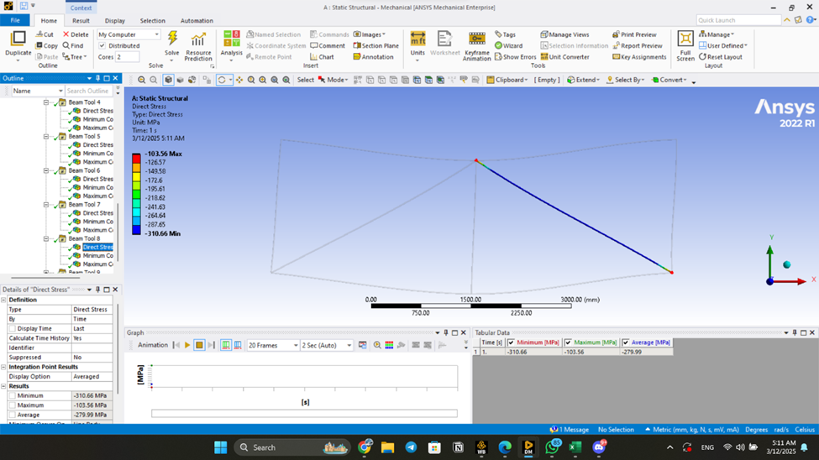

J
Description
Get stress on each beam.

Step 7: Postprocessing – Stresses

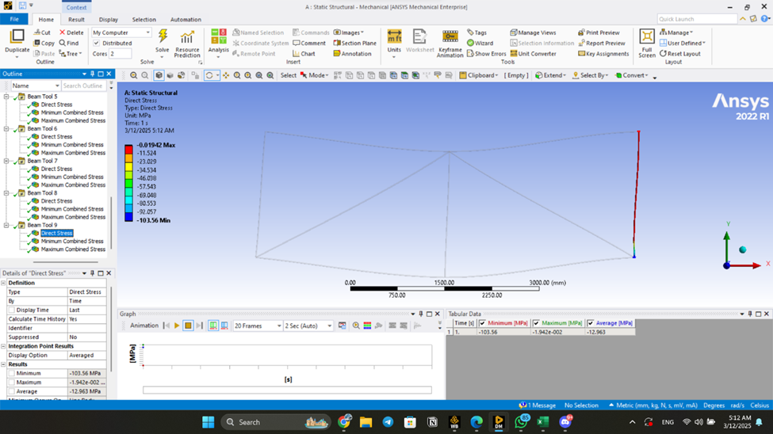

J
Description
Put results in a table.

Step 8: Postprocessing – Tabulate Results

J
Directional Deformation (y)
Directional Deformation (x) | [-0.023mm, 0.724 mm]
Total Deformation | [0.00mm, 1.55 mm]
Stress on Bar 1 (1-2) | [-51.78 MPa, 0.0057 MPa]
Stress on Bar 2 (2-3)
Stress on Bar 3 (3-4) | [-103.56 MPa, -0.019 MPa]
Stress on Bar 4 (4-5) | [-119.07 MPa, -0.025 MPa]
Stress on Bar 5 (5-6) | [-129.29 MPa, -64.65 MPa]
Stress on Bar 6 (6-1) | [-64.65 MPa, -0.010 MPa]
Stress on Bar 7 (2-5) | [-119.07 MPa, -0.0089 MPa]
Stress on Bar 8 (1-5) | [-155.33 MPa, -51.78 MPa]
Stress on Bar 9 (3-5) | [-310.66 MPa, -103.56 MPa]

Results

Using APDL

Description
- Preprocessing
  - Engineering Data: adjusting real constants and material properties
  - Model: adding nodal locations, element connections, nodal constraints, and loads
- Postprocessing
  - Plotting model
  - Listing nodal displacements, element stresses, element forces.

APDL SCRIPT Steps

APDL SCRIPT

APDL SCRIPT

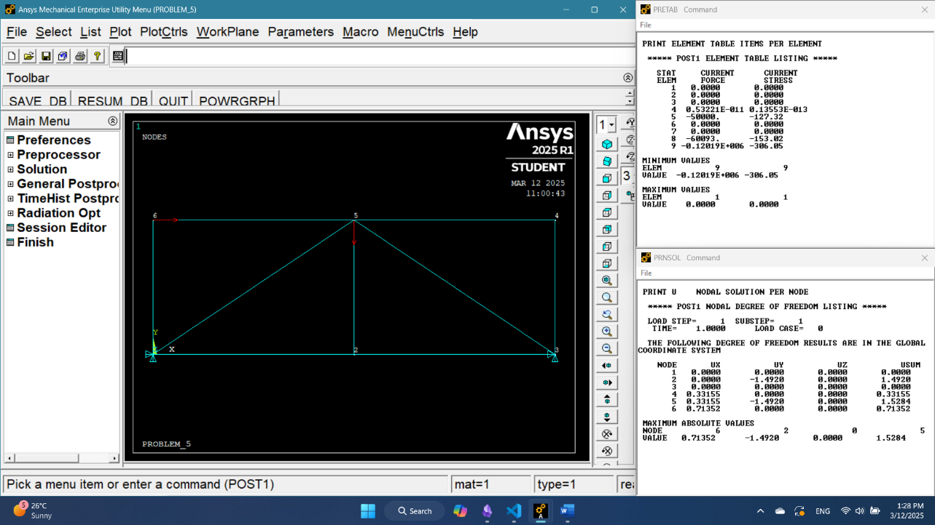
J

NODE | UX (mm) | UY (mm) | UZ (mm) | USUM (mm)
1 | 0 | 0 | 0 | 0
2 | 0 | -1.492 | 0 | 1.492
3 | 0 | 0 | 0 | 0
4 | 0.33155 | 0 | 0 | 0.33155
5 | 0.33155 | -1.492 | 0 | 1.5284
6 | 0.71352 | 0 | 0 | 0.71352

Bar | Force (N) | Stress (MPa)
Bar 1 (1-2) | 0 | 0
Bar 2 (2-3) | 0 | 0
Bar 3 (3-4) | 0 | 0
Bar 4 (4-5) | 5.32E-12 | 1.36E-14
Bar 5 (5-6) | -50000 | -127.32
Bar 6 (6-1) | 0 | 0
Bar 7 (2-5) | 0 | 0
Bar 8 (1-5) | -60093 | -153.02
Bar 9 (3-5) | -1.20E+05 | -306.05

Results

